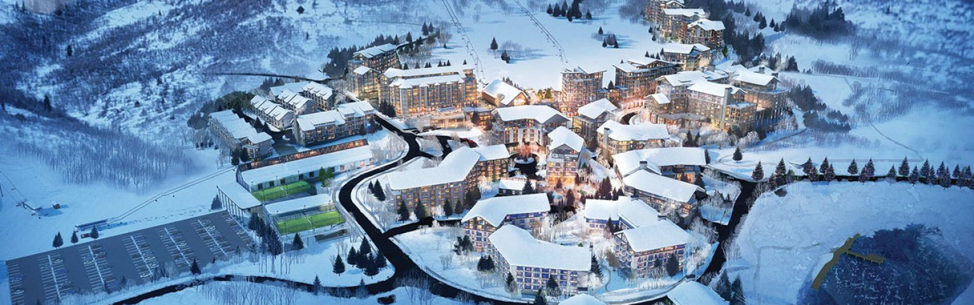

EX Utah Development, LLC Voluntary Cleanup Program (VCP) Now Underway

Extell Development Company
MIDA Project Area, Wasatch County, Utah

The Mayflower Mountain Resort project, named for historic mining claims on site, is comprised of 6,800 acres adjacent to Deer Valley Resort in Utah. Extell has begun creating a luxury resort with easy and direct vehicle access and a walkable resort village experience that ties directly into alpine skiing.

Extell, which in 2019 was approved as part of the Military Development Installation Authority (MIDA) project area, has prioritized as its first order of business the voluntary cleanup of the site under the State of Utah’s Voluntary Cleanup Program (VCP).

Although the site has never been developed and sat vacant since the early 1970s, no major efforts had been undertaken by previous landowners or mining companies to address the remnants of past mining activity. Extell has gathered the foremost environmental experts from Utah and throughout the country to begin onsite remediation – long overdue for such a beautiful property.
Key messages regarding the site Voluntary Cleanup Program:

- First written reports of the Mayflower site’s use –described as mine prospects and claims – appear in the 1870s.
- The historical Blue Ledge Mining District, of which Mayflower is part of, was established in 1870, whereby localized portions of the property and contiguous off-site lands were mined/ prospected for precious metal ores including silver, lead, zinc and gold.
- According to the United States Bureau of Mines, Mayflower ranked sixth among gold-producing mines in the United States Mineral Year Book in 1970.
- Known mines previously active on the site include Mayflower, Glencoe, Star of Utah, Flagstaff and Park Galena.

- 1

- Localized mining |prospecting continued at the property until 1972, when the mine was closed.
- No remediation of the property occurred between 1972 and present day.
- Prior to purchase, Extell completed Phase I Environmental Site Area (ESA) in December 2016) and sampling to determine impact and if it fit the State’s Voluntary Cleanup Program.
- Initial Phase II site sampling continued through June 2017.
- May 2017: Extell applied to enter into the Voluntary Cleanup Program (VCP) for the Mayflower property (t 2,278 acres) and extensive Site Characterization sampling continued under the VCP through November 2018.
- July 2017: Extell was accepted into the VCP program as analysis and characterization of the property continued.
- A plan for remediation, called a Remedial Action Plan (RAP,) was approved spring of 2019 for Phase 1 of the property (the entire Village area).
- The implementation of the cleanup is expected to be a multi-million-dollar endeavor.

The main development and Village portion of the property is located on Utah Highway 40, exit 8, approximately 40minutes from Salt Lake City International Airport (SLC). It is oriented with ski terrain extending into the heart of the Village and the majority of runs contemplated to encompass views of the lake to the east, the Jordanelle Reservoir and its associated state park, which attracts approximately 600,000 visitors annually.

Currently an undeveloped site, planners and stakeholders see it as the greatest potential ski village development since the 1980s; it’s anticipated to be one of the most spectacular alpine resort villages to be built in decades.

Development of a fully integrated mountain village with 1,560 residential units; 825 hotel rooms plus commercial space; 250,000 retail and commercial square feet; parking in the village for day-skiers in addition to dedicated parking for all on-site facilities; a 68,000-square-foot recreation complex and 95,000 square feet for employee | workforce and attainable housing.

2

